***Speaker Part***

For the duration of the piece you are asked to read through this part without any regard to the other performers. There is no conductor and, for the most part, there is no coordinated ensemble work. The text should not be read in an especially theatrical manner; the tone should fairly dry, but not without interpretive nuance.

Pages read from top to bottom and left to right. Space relates loosely to time. Blank space between events (potentially including entire blank pages) indicates loosely proportional pauses. Although there is no strictly defined timecode and page lengths will vary widely, the majority of pages should take between 40 and 80 seconds to play through.

Occasional instructions written inside boxes call for special actions such as listening to and imitating other performers or repeating passages. If any boxed instruction asks you to wait until you hear something happen before proceeding, you should continue regardless if more than about a minute passes. Fermatas with time codes will ask you to pause reading for a loosely defined length of time:

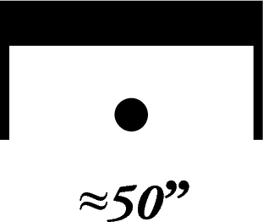

To begin the work, every person begins at the top of their first page. When you reach the end of your part, simply stop reading. The performance will be over once no performer has made a deliberate sound for over a minute. If you are the last performer remaining at the end of the piece, boxed instructions asking you to wait or listen to other performers should be ignored.